List of Tables

Table 1: Effects of sentinel presence and generalized environment on the allocation of time to each behavior 8

Table 2: Results of the linear mixed models fit to the mean bout duration 10

Table 3: Result of the linear mixed model fit to forager peck rate 16

Table 4: Results of generalized linear mixed model fit to the number of transitions performed by foragers 19

List of Figures

Figure 1: Map of observations from Crowkemon Go and sampling locations used during the data collection phase 3

Figure 2: Proportion of foraging time allocated to each behavior by foragers in commercial and green areas 7

Figure 3: Mean bout duration of foragers in commercial and green areas 9

Figure 4: Mean foraging bout duration of crows foraging in small and large groups 12

Figure 5: Foraging bout duration decreasing with increasing disturbance frequency 13

Figure 6: Mean peck rate of foragers in commercial and green areas 15

Figure 7: Peck rate increasing with increasing disturbance frequency 17

Figure 8: Number of transitions performed by foragers in commercial and green areas 18

Figure 9: Transitions from foraging to alert behavior increases as disturbance frequency increases 20

Methods

Site Selection

We launched a community science initiative in the greater St. Catharines and Niagara region called Crowkemon Go (www.crowkemon.weebly.com) in spring 2022. Community members were invited to report the location of crows spotted during the spring months to locate areas with a high likelihood of finding crows. In total, the community recorded 221 crow sightings using Crowkemon Go between January and May 2022. From April-May 2022, we visited potential observation sites and baited them with whole peanuts to attract crows and reinforce an association of food with these locations. We limited data collection to the summer months (June-September 2022) when nestlings are fledging, and groups are less tightly bound by the territory immediately surrounding the nest. One site was selected for recurrent sampling (Fairview Park, 43°10'57.4"N 79°14'44.9"W). We also visited areas with many crow sightings for opportunistic sampling, as the presence of crows was not guaranteed at other potential recurrent sampling locations ().

Field observation

Data collection was performed during the 2-3 hours following sunrise (approx. 6-9AM). No sampling was performed when it was raining or during adverse weather (e.g., thunderstorm or heatwave). Upon arriving at the recurrent sampling location, a Nikon D5300 camera with a 70-300mm Nikkor lens was set up on a tripod a minimum of 15m away from a concrete pad (predetermined bait location). If crows were already foraging in the area, we would begin recording immediately and not bait the site. If not, an observer approached and visibly dropped 30g of Cheez-Its, then returned to the camera. If crows were on-site, recording would start immediately, whereas if the crows were absent, a crow-caller would be used for 20 minutes (1 5s. call per min, 5 mins on, 5 mins off) to attract them. We would then begin recording upon the arrival of the crows and recorded up to maximum of 20 minutes. The recording was stopped if the crows vacated the area for longer than 5 minutes and we remained in the area for 10 minutes post-departure in case the crows returned. If the crows returned, we would continue the trial. For opportunistic sampling, we looked for crows using Crowkemon Go as a guide. If we found crows that were already foraging, we would set up in the same manner as for recurrent sampling and did not bait the site. Conversely, if the crows were not already foraging, we would bait the site as we did for recurrent sampling.

The presence of a sentinel, whether heard or seen, was announced verbally by the observer during the recording, and group size and disturbances (e.g., pedestrians, pets, vehicles) were also verbally noted. For each location, we classified the type of environment using St. Catharine municipal zoning maps. The ‘generalized environment’, a factor used for all subsequent analyses, was categorized by labeling all types of green spaces as “green”, and all types of

Figure : Map of observations from Crowkemon Go and sampling locations used during the data collection phase

The black dots represent observations collected from Crowkemon Go, and the circular icons are sampling locations. The single recurrent site used is in green, with the two failed sites in red. Opportunistic sampling sites are in yellow. Focal area was limited to the St. Catharines & Niagara region.

commercial area as “commercial” (). Disturbance frequency was calculated by dividing the number of disturbances by the duration of the recording. Group size was binned into two categories: small (4) and large (5).

Video Analysis

For video analyses, we used the Behavioral Observation Research Interactive Software (BORIS v.8.9.4) [1]. We classified behaviors as either “foraging” or “alert”, with “alert” being the behavior of most vigilance, and “foraging” the behavior of least vigilance due to the inability of an individual to effectively scan their surroundings while pecking at or looking for food on the ground. The behaviors were defined by the position of the focal individual’s head and body posture (). We recorded the duration of bouts of each behavior for every individual and bouts of less than 0.01s. were removed. Since not all bouts of movement were recorded in their entirety, “moving” behavior was excluded from these analyses. We then calculated the proportion of time spent performing each behavior. Behaviours were recorded separately for if a sentinel was present or not. Therefore, the same individual could have two observations if it foraged or was alert in both the presence and absence of a sentinel.

In addition to these behaviors, we also recorded the number of pecks (handling food with their beaks for the purpose of eating it) to quantify foraging effort. The peck rate (per min) was calculated for every individual by dividing the total number of pecks at food performed by the total duration of “foraging” behavior. Individuals that did not forage were excluded.

Statistical Analysis

All statistical analysis was performed in the R environment (v.4.2.2; R Core Team 2022) [2]. We first ran chi-squared tests to determine if the generalized environment, the group size, or the disturbance frequency affected the likelihood of a sentinel being present in our videos.

To determine the effects of generalized environment and sentinel presence on the proportion of time foragers allocated to each behavior, we used the “lm” function in the R Stats package [2] to fit a linear model using behavior type, sentinel presence and generalized environment as fixed effects.

To determine the effects of generalized environment and the presence of a sentinel on the duration of bouts of all behaviors, we used the function “rlmer” from the “robustlmm” package [3] to fit a robust linear mixed model to the log-transformed duration of bouts with behavior type, sentinel presence, generalized environment, group size, and bait presence as fixed factors, the disturbance frequency (per min) as a fixed effect and the individual ID as a random effect. We then post-hoc fitted robust linear mixed models on each behavior to determine the effects of sentinel presence and generalized environment on each behavior. The duration of bouts was log-transformed to normalize the distribution.

To determine the effects of sentinel presence and generalized environment on foraging rate, we used the function “rlmer” from the “robustlmm” package [3] to fit a robust linear mixed model to the peck rate of foragers using sentinel presence, generalized environment, group size, and bait presence as fixed factors, the disturbance frequency (per min) as a fixed effect, and the individual ID as a random effect.

Finally, we counted the number of transitions from each behavior to determine the effects of sentinel presence and generalized environment on the frequency of each transition type. Using the “glmer” function from the “lme4” package [4], we fitted a generalized linear mixed model using a Poisson distribution to the number of occurrences of each transition. Sentinel presence, generalized environment, and bait presence were used as fixed factors, the disturbance frequency (per min) was used as a fixed effect, and the total number of transitions performed by the individual was used as a random effect in the model.

Post hoc estimated marginal means tests were performed as appropriate using the “emmeans” function from the “emmeans” package [5]. P-values were corrected using the “fdr” method, and the results were averaged over the unused categorical factors.

Results

Sentinel presence

Neither the generalized environment (χ2 = 0.122, df = 1, p = 0.727; Figure S 1), group size (χ2 = 0.248, df = 1, p = 0.618; Figure S 2), or the disturbance frequency (χ2 = 2.033, df = 2, p = 0.362; Figure S 2) significantly affected the likelihood of a sentinel being present.

Allocation of time to each behavior

We made 64 observations across 25 videos. 81 observations were made for the proportion data. Crows allocated similar proportions of time to foraging and vigilance ( = 0.026, SE = 0.024, t-stat = 1.160, p = 0.248; , ), and neither the presence of a sentinel ( = -0.034, SE = 0.023, t-stat = -1.431, p = 0.154; Figure 2, ) or the generalized environment ( = 0.034, SE = 0.023, t-stat = 1.463, p = 0.146; , ) had an effect on the proportion of time allocated to either alert or foraging behavior.

Duration of bouts of all behaviors

In total, 5091 bouts were recorded, of which 2110 bouts were of “alert” behavior, 1787 bouts were of “foraging” behavior, and 1173 bouts were of “movement”. We removed 21 observations of duration less than 0.01s were removed. Bouts of alertness and foraging were significantly different ( = -0.256, SE = 0.051, t-stat = -5.002, p = <0.001; Figure 3, Table 2), with bouts of alertness being significantly shorter than bouts of foraging. Sentinel presence increased the duration of all bouts significantly ( = 0.197, SE = 0.072, t-stat = 2.741, p = 0.006; Figure 3, Table 2). Bouts of all behaviors in green areas were significantly longer than those in commercial areas ( = 0.353, SE = 0.087, t-stat = 4.048, p = <0.001; Figure 3, Table 2). Disturbance frequency had a significant effect on the duration of all bouts ( = -0.088, SE = 0.030, t-stat = -2.975, p = 0.003; Figure S 3, Table 2), with bout duration decreasing as disturbance frequency increased. The interaction between generalized environment and sentinel presence had a significant effect ( = -0.252, SE = 0.088, t-stat = -2.863, p = 0.004; Figure 3, Table 2). The interaction between behavior type and generalized environment was also significant ( = -0.202, SE = 0.054, t-stat = -3.769, p = <0.001; Figure 3, Table 2).

Post-hoc pairwise testing revealed significant differences in the duration of bouts of all behaviors. In commercial areas, the presence of a sentinel increased the duration of bouts ( = -0.157, SE = 0.065, z-ratio = -2.402, p = 0.049; ). In the absence of a sentinel, foragers in green areas had longer bouts ( = -0.252, SE = 0.082, z-ratio = -3.074, p = 0.013; ). Foragers in commercial areas and in the absence of a sentinel had marginally shorter bouts than in green areas and in the presence of a sentinel ( = -0.157, SE = 0.072, z-ratio = -2.117, p = 0.059; ). All other comparisons were not significant (p < 0.343; ).

Figure : Proportion of time allocated to each behavior by foragers in commercial and green areas

Table : Effects of sentinel presence and generalized environment on the allocation of time to each behavior

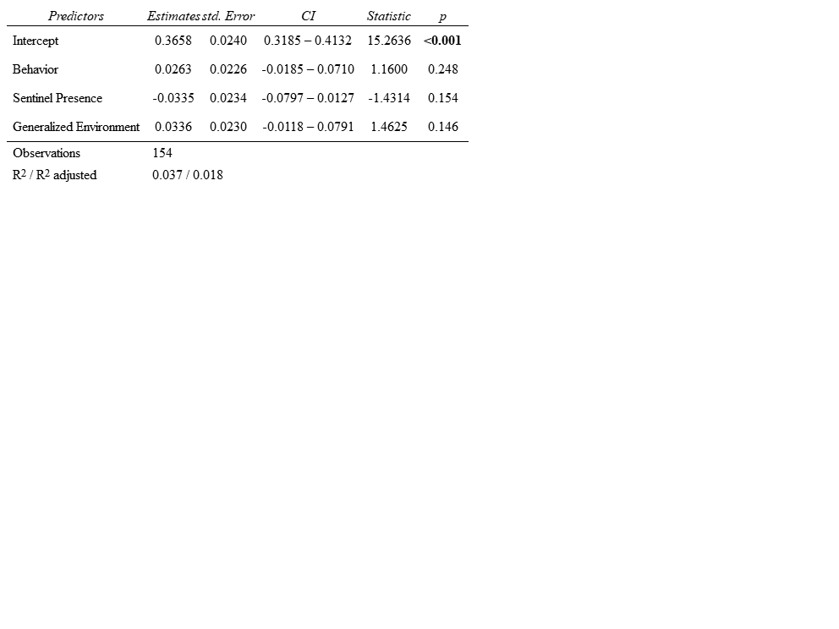

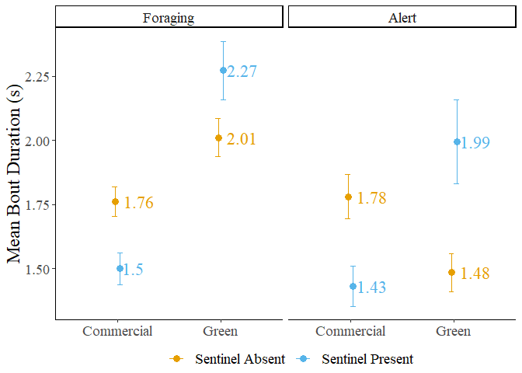

Figure : Mean bout duration of foragers in commercial and green areas

The dots represent the mean value, and the error bars represent the standard error.

Table : Results of the linear mixed models fit to the mean bout duration

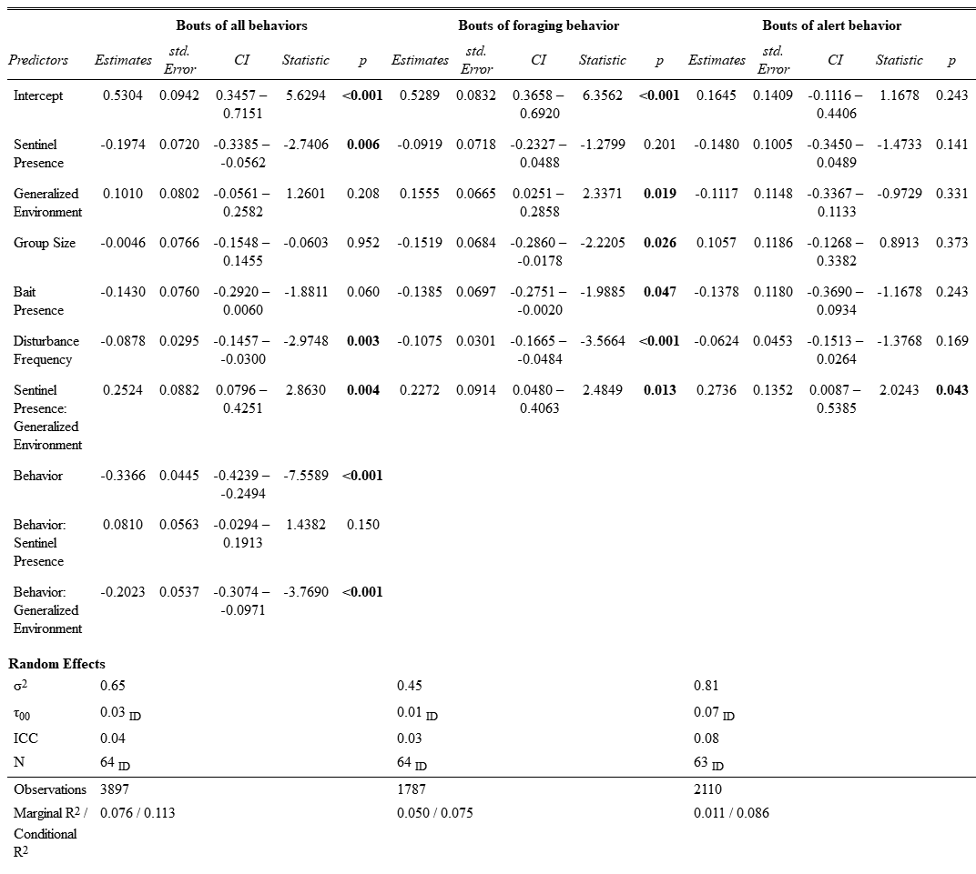

Duration of bouts of “foraging” behavior

Sentinel presence had no significant effect on the duration of bouts of foraging ( = 0.092, SE = 0.072, t-stat = 1.280, p = 0.201; Figure 3, Table 2). Generalized environment had a significant effect on the duration of bouts of foraging behavior, with bouts being longer in green areas ( = 0.383, SE = 0.078, t-stat = 4.919, p = <0.001; Figure 3, Table 2). Larger groups had significantly longer bouts of foraging behavior ( = -0.152, SE = 0.068, t-stat = -2.221, p = 0.026; Figure 4, Table 2). The presence of bait decreased the duration of foraging bouts ( = -0.139, SE = 0.070, t-stat = -1.989, p = 0.047; Figure S 4, Table 2). Increasing disturbance frequency significantly decreased the duration of foraging bouts ( = -0.108, SE = 0.030, t-stat = -3.566, p = <0.001; Figure 5, Table 2). The interaction between generalized environment and sentinel presence was significant ( = -0.227, SE = 0.091, t-stat = -2.485, p = 0.013; Figure 3, Table 2).

Post hoc tests revealed significant differences in the duration of bouts of foraging behavior. In the absence of a sentinel, foragers in green areas had significantly longer bouts of foraging behavior than in commercial areas ( = -0.383, SE = 0.078, z-ratio = -4.919, p < 0.001; Table S 3). In the presence of a sentinel, foragers in green areas also had significantly longer bouts of foraging behavior than in commercial areas ( = -0.156, SE = 0.067, z-ratio = -2.337, p = 0.029; Table S 3). The presence of a sentinel had no significant effect on the duration of bouts of foraging behavior when in commercial areas ( = -0.092, SE = 0.072, z-ratio = -1.280, p = 0.200; Table S 3). In the presence of a sentinel and in green areas, foragers had a significantly longer bouts of foraging behavior than in the absence of a sentinel and in commercial areas ( = -0.247, SE = 0.066, z-ratio = -3.738, p < 0.001; Table S 3). When in the absence of a sentinel and in green areas, foragers also had significantly longer bouts of foraging behavior than in the presence of a sentinel and in commercial areas ( = -0.291, SE = 0.087, z-ratio = -3.340, p = 0.002; Table S 3). In green areas, foragers in the presence of a sentinel had marginally shorter bouts of foraging behavior than in the absence of a sentinel ( = 0.135, SE = 0.068, z-ratio = 1.977, p = 0.058; Table S 3).

Duration of bouts of “alert” behavior

Sentinel behavior, generalized environment, group size, bait presence and disturbance frequency had no significant effect on the duration of bouts of alert behavior (p < 0.141; Table 2). The interaction between sentinel behavior and generalized environment was significant ( = -0.274, SE = 0.135, t-stat = -2.024, p = 0.043; Figure 3, Table 2). Post hoc pairwise t-tests revealed no significant differences in the duration of bouts of alert behavior.

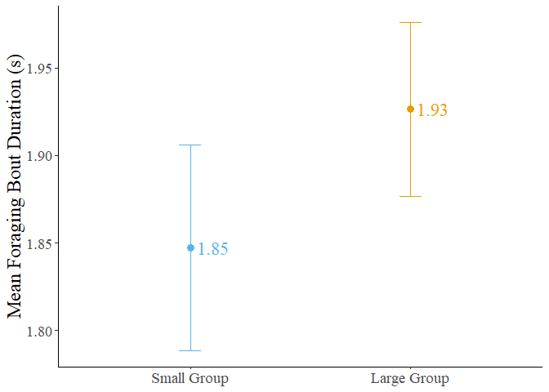

Figure : Mean foraging bout duration of crows foraging in small and large groups

The dots represent the mean value, and the error bars represent the standard error.

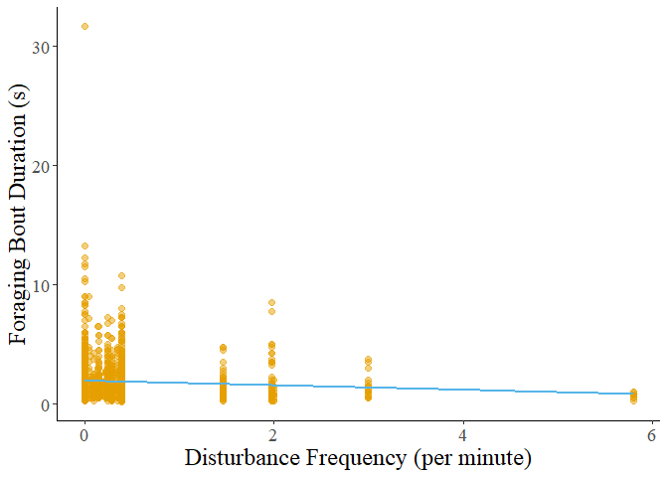

Figure : Foraging bout duration decreasing with increasing disturbance frequency

Foraging rate

We calculated the peck rate (per min) for 81 observations. Two observations were removed as the individual did not perform any foraging behavior. Neither the presence of a sentinel nor the generalized environment alone had a significant effect on the peck rate of foragers (p > 0.702; Figure 6, Table 3). The presence of bait significantly increased the peck rate of foragers ( = 13.990, t-stat = 2.231, p = 0.020; Figure S 5, Table 3). Peck rate increased significantly with disturbance frequency ( = 5.290, t-stat = 2.312, p = 0.021; Figure 7, Table 3). The interaction between generalized environment and disturbance frequency also significantly affected peck rate ( = 16.150, t-stat = 3.046, p = 0.002; Figure 7, Table 3).

Pathway analysis

Transitions from foraging to alert behavior were significantly affected by generalized environment (IRR = 2.115, SE = 0.0.769, z-stat = 2.062, p = 0.039; Figure 8, Table 4), disturbance frequency (IRR = 0.728, SE = 0.109, z-stat = -2.130, p = 0.033; Figure 9, Table 4), and the interaction between generalized environment and sentinel presence (IRR = 0.199, SE = 0.098, z-stat = -3.298, p = 0.001; Figure 8, Table 4).Transitions from foraging to pecking were significantly affected by the presence of bait, with more transitions occurring in the presence of bait (IRR = 1.710, SE = 0.384, z-stat = 2.386, p = 0.017; Figure S 6, Table 4). All other factors did not affect this transition (p-value > 0.436; Table 4). Transitions from pecking to alert behavior were similarly affected by the presence of bait, significantly increasing when bait was present (IRR = 2.204, SE = 0.538, z-stat = 3.238, p = 0.001; Figure S 6, Table 4). All other factors did not affect this transition (p-value > 0.235; Table 4). Transitions from alert to foraging behavior were not significantly affected by any factors, however, bait presence had a marginally significant effect (IRR = 1.513, SE = 0.351, z-stat = 1.789, p = 0.074; Figure S 6, Table 4), increasing the number of transitions from alert to foraging.

Post hoc testing on the number of transitions from foraging to alert behavior revealed significant differences. In green areas, individuals performed more transitions from foraging to alert behavior when in the presence of a sentinel ( = -1.124, SE = 0.346, z-ratio = -3.250, p = 0.007; Table S 4). In the presence of a sentinel, individuals exhibited marginally more of the same transitions in green areas ( = -0.749, SE = 0.364, z-ratio = -2.062, p = 0.079; Table S 4). However, in the absence of a sentinel, individuals exhibited marginally more transitions from foraging to alert behavior in commercial areas ( = 0.864, SE = 0.372, z-ratio = 2.321, p = 0.061; Table S 4).

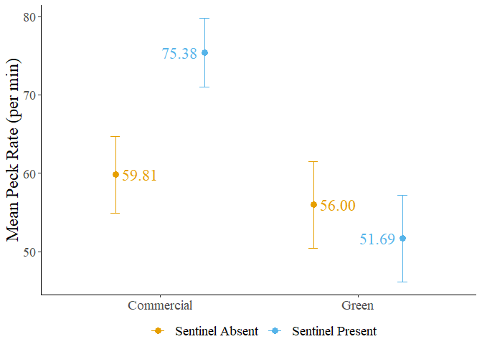

Figure : Mean peck rate of foragers in commercial and green areas

The dots represent the mean value, and the error bars represent the standard error.

Table : Result of the linear mixed model fit to forager peck rate

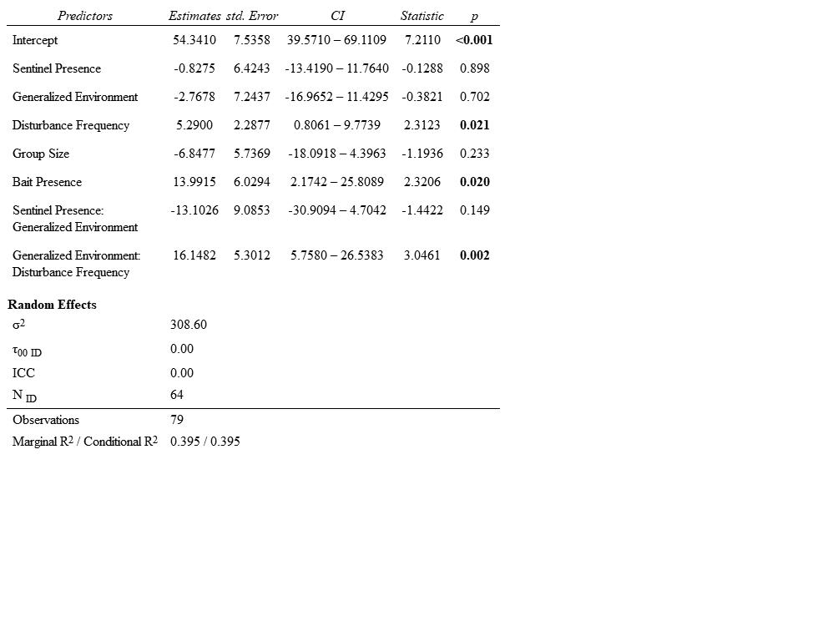

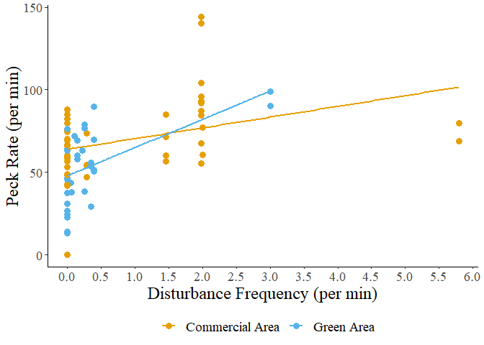

Figure : Peck rate increasing with increasing disturbance frequency

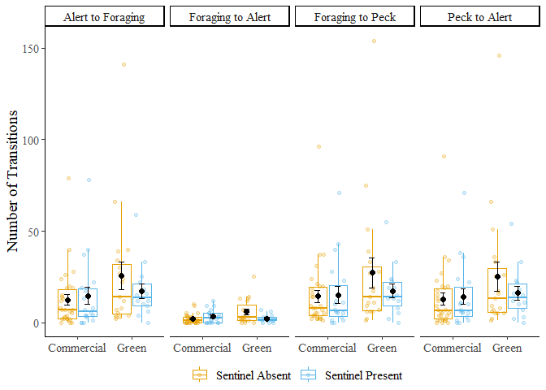

Figure : Number of transitions performed by foragers in commercial and green areas

The black dots represent the mean value, and the error bars represent the standard error.

Table : Results of generalized linear mixed model fit to the number of transitions performed by foragers

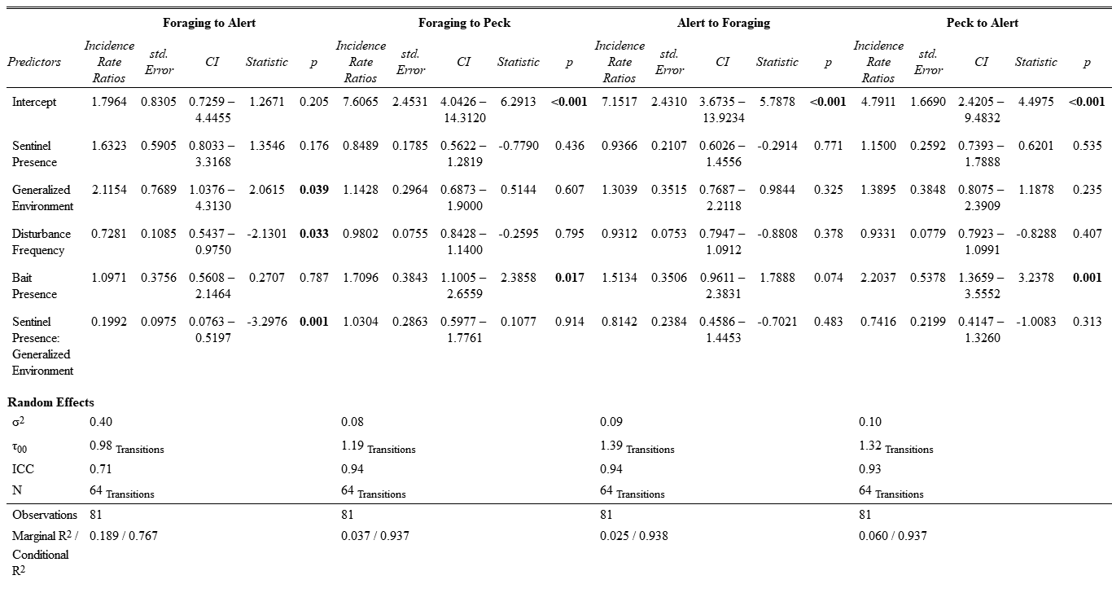

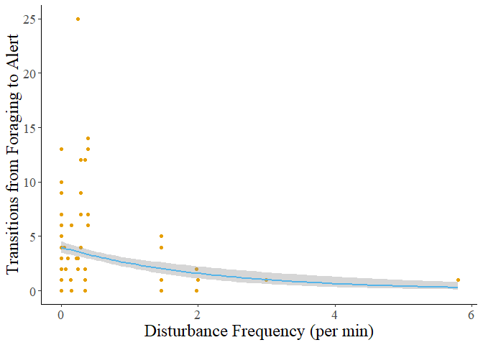

Figure : Transitions from foraging to alert behavior increases as disturbance frequency increases

The grey shadow represents the standard error of the curve.

References

1. Friard O, Gamba M. 2016 BORIS: a free, versatile open-source event-logging software for video/audio coding and live observations. *Methods Ecol. Evol.* **7**, 1325–1330. (doi:10.1111/2041-210X.12584)

2. R Core Team. 2022 R: the R project for statistical computing.

3. Koller M. 2016 Robustlmm: an R package for robust estimation of linear mixed-effects models. *J. Stat. Softw.* **75**, 1–24. (doi:10.18637/jss.v075.i06)

4. Bates D, Mächler M, Bolker B, Walker S. 2015 Fitting linear mixed-effects models using lme4. *J. Stat. Softw.* **67**, 1–48. (doi:10.18637/jss.v067.i01)

5. Lenth RW. 2023 Emmeans: estimated marginal means, aka least-squares means.

Supplemental Material

List of Supplemental Tables

Table S 1: Explanation of generalized environment 22

Table S 2: Ethogram of behaviors analyzed during foraging events 23

Table S 3: Results of post hoc tests on bout duration 27

Table S 4: Result of post hoc test performed on the number of transitions from foraging to alert behavior 31

List of Supplemental Figures

Figure S 1: Sentinel presence in commercial and green areas 24

Figure S 2: Frequency plots of observations in the presence and absence of a sentinel 25

Figure S 3: Decreasing bout duration of all behaviors in response to increasing disturbance frequency 26

Figure S 4: Mean bout duration in the presence and absence of bait 28

Figure S 5: Mean forager peck rate in the presence and absence of bait 29

Figure S 6: Number of transitions performed by foragers in the presence and absence of bait 30

Table S : Explanation of generalized environment

|  |  |
| --- | --- |
| Generalized Environment | Zones included |
| Commercial Area | Arterial Commercial, Business Commercial Employment, Community Commercial, Major Commercial |
| Green Area | Major Green Space, Minor Green Space |

Each zone type was identified using the St. Catharines and Niagara zoning maps for each sampling location.

Table S : Ethogram of behaviors analyzed during foraging events

|  |  |  |  |
| --- | --- | --- | --- |
| Behavior | Code | Definition | Illustration |
| Foraging | Head Down | Focal individual is stationary and has its head downwards or in a non-upright position, either pecking or handling food, looking for food, or engaging in other behaviors that make vigilance ineffective (e.g. preening). |  |
| Moving | Moving | Focal individual is moving, either by flying, hopping (leaping), or walking. |  |
| Alert | Head Up | The focal individual is stationary and has its head and body in an upright position. Individuals can have a mobile (scanning) or immobile head but must not be looking downwards. Individuals can be handling food. |  |

*All illustrations are under creative commons license (copyright-free)*

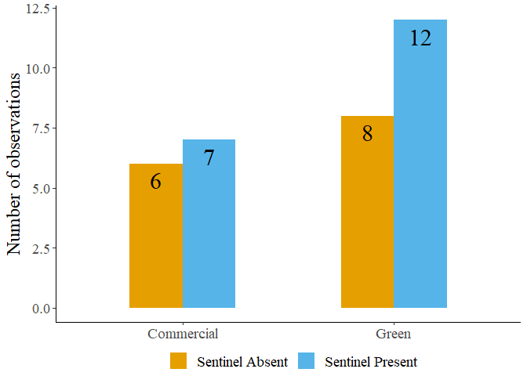

Figure S : Sentinel presence in commercial and green areas

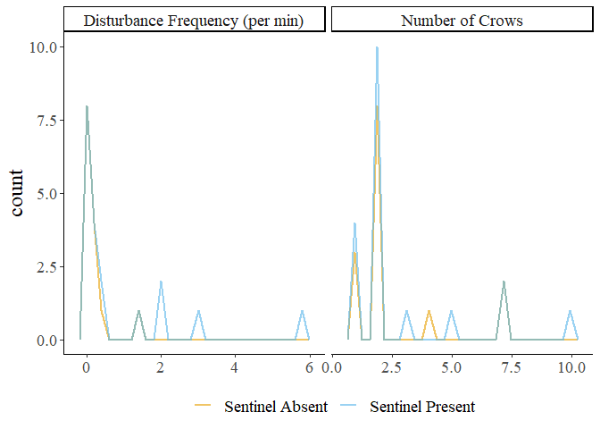

Figure S : Frequency plots of observations in the presence and absence of a sentinel

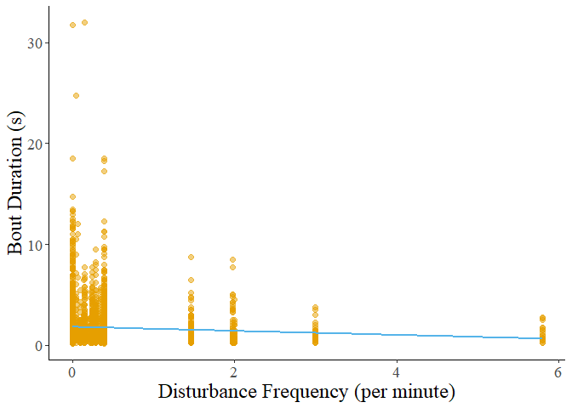

Figure S : Decreasing bout duration of all behaviors in response to increasing disturbance frequency

Table S : Results of post hoc tests on bout duration

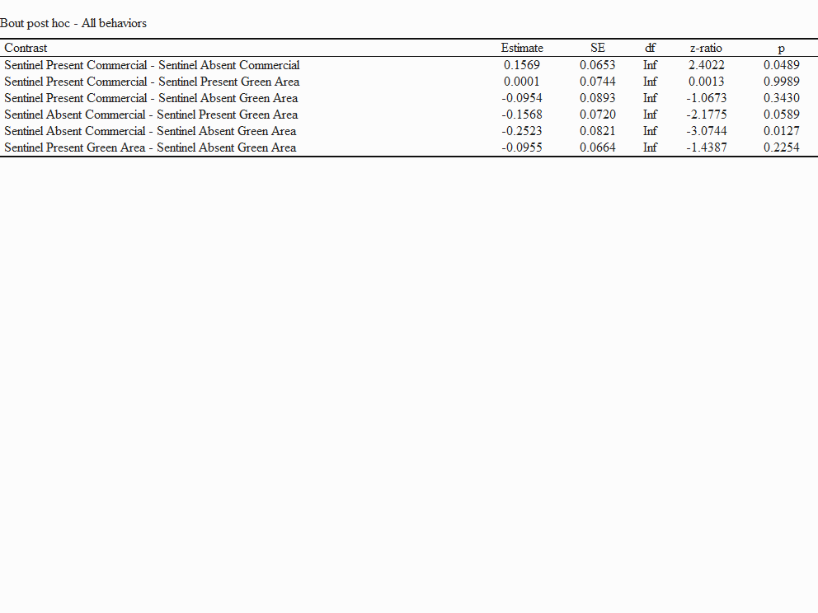

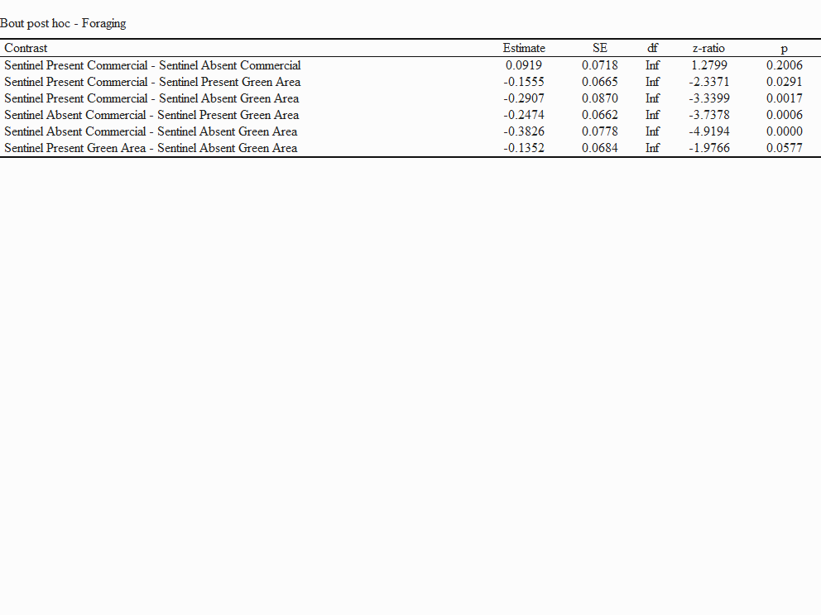

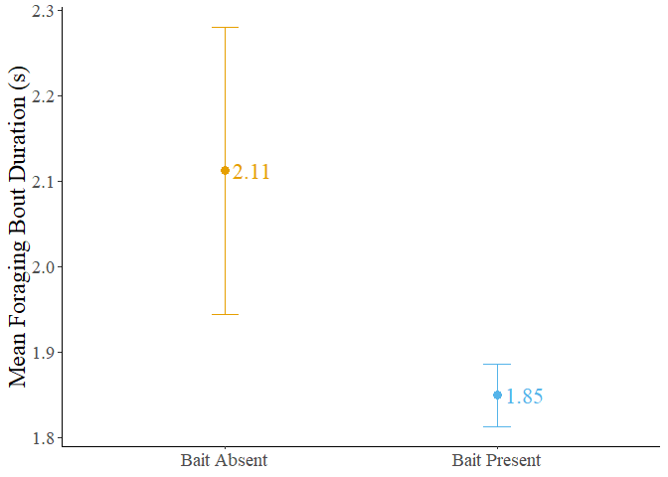

Figure S : Mean bout duration in the presence and absence of bait

The dots represent the mean value, and the error bars represent the standard error

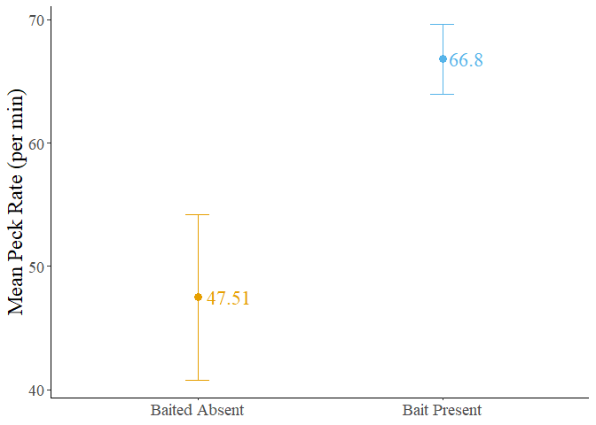

Figure S : Mean forager peck rate in the presence and absence of bait

The dots represent the mean value, and the error bars represent the standard error.

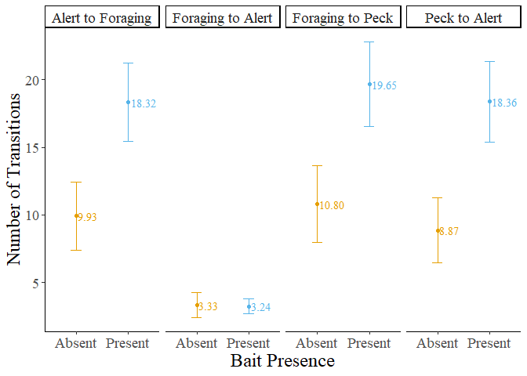

Figure S : Number of transitions performed by foragers in the presence and absence of bait

The dots represent the mean value, and the error bars represent the standard error.

Table S : Result of post hoc test performed on the number of transitions from foraging to alert behavior

